Stalin's angel of death: Memoir of the world's most successful female sniper who killed over 300 reveals how she formed an unlikely friendship with America's First Lady
- Lyudmila Mikhailovna Pavlichenko was world's most deadly female sniper
- After the war she appeared on postage stamps and a feature film was made
- Her grisly tally saw her meet US President Roosevelt, Churchill and Stalin
- She also struck up an unlikely friendship with the First Lady, Eleanor Roosevelt
Read more: http://www.dailymail.co.uk/news/article-5513463/Stalins-angel-death-worlds-successful-female-sniper.html#ixzz5CS30nnBJ
Follow us: @MailOnline on Twitter | DailyMail on Facebook

For two days in January 1942, the Russians concealed themselves in a freezing trench, waiting for the Nazi sniper to reveal himself.
Just as dawn was breaking on the third morning, their binoculars revealed a German cautiously picking his way across a ruined railway bridge overlooking the besieged city of Sebastopol.
It was undoubtedly the sniper who, in the previous 48 hours, had slaughtered five members of the Red Army, including a battalion commander, but he quickly disappeared from view.
The only way to establish exactly where he had hidden was to wait for a tell-tale muzzle flash from his rifle.
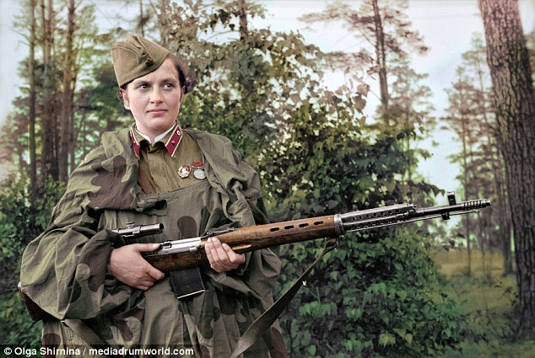
+11

Lyudmila Mikhailovna Pavlichenko had married on the battlefield just a few weeks before. Aged 25, she was also a mother with a young child from a previous relationship
It came soon enough, when the German fired at a man-sized mannequin that the Russians’ own crackshot, Senior Sergeant Pavlichenko, had ordered to be placed as bait in no-man’s land. ‘Finally I’ve got you, you Nazi b*****d,’ Pavlichenko thought, and squeezed the trigger.
The bullet hit the luckless German between the eyes and his body plummeted to the ground.
Pavlichenko scrambled down the gorge to where the dead man lay to remove paperwork from his tunic. Back at headquarters, the Russian colonel scrutinised the documents.
‘He has a tally of 215,’ the colonel announced. ‘How many do you have?’
‘227,’ replied his sharpshooter.
‘So you were well matched?’
Pavlichenko nodded. There had indeed been little difference between the two ace snipers.
Except for one thing – Pavlichenko was a woman.
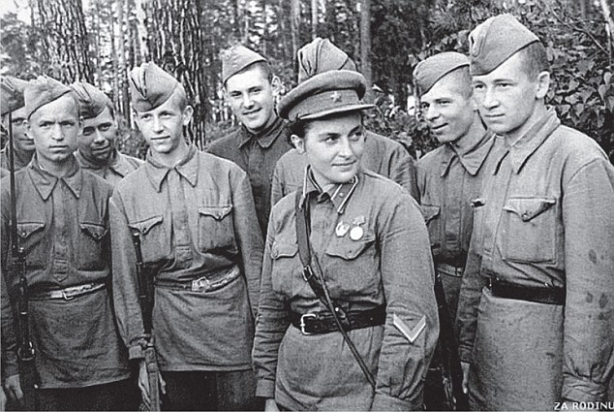
+11

During the war – and indeed after it – her prowess with a rifle became legendary. Pavlichenko is now credited as being the most successful female sniper ever, with an astonishing 309 confirmed kills
Lyudmila Mikhailovna Pavlichenko had married on the battlefield just a few weeks before. Aged 25, she was also a mother with a young child from a previous relationship.
During the war – and indeed after it – her prowess with a rifle became legendary. Pavlichenko is now credited as being the most successful female sniper ever, with an astonishing 309 confirmed kills.
That grisly achievement saw her not only being taken from the front line to meet all three Allied leaders – Churchill, Roosevelt and Stalin – but also to receive her country’s highest award, the Hero of the Soviet Union.
After the war, she would appear on postage stamps, while a feature film was made about her in 2015. Now, finally, her autobiography is being published in English for the first time.
Pavlichenko’s life story makes for remarkable reading, especially today, when the British Armed Forces are only now finally accepting that women make redoubtable front line combat troops.
Through her own ability, bravery and single-mindedness, she was able to overcome social, military and cultural barriers, and showed the men that she was far more capable than they were.
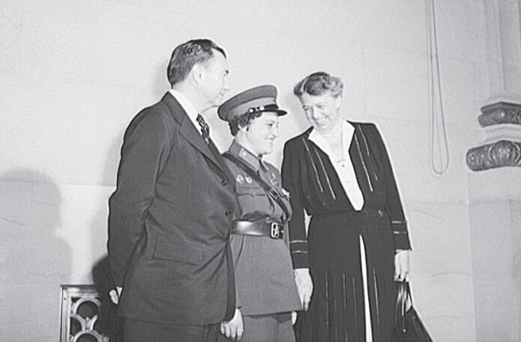
+11

An unlikely friendship: Lyudmila, centre, with Franklin and Eleanor Roosevelt
First lady Eleanor Roosevelt rallies to sell war bonds in 1944
Loaded: 0%
Progress: 0%
0:00
Previous
Play
Skip
Mute
Current Time0:00
/
Duration Time0:18
Fullscreen
Need Text
Read more: http://www.dailymail.co.uk/news/article-5513463/Stalins-angel-death-worlds-successful-female-sniper.html#ixzz5CS3M4seR
Follow us: @MailOnline on Twitter | DailyMail on Facebook

Pavlichenko was born in Ukraine in July 1916. Her father was a member of the NKVD – the Soviet police and security service that was a forerunner to the notorious KGB.
Pavlichenko was raised to have an unflinching loyalty to the communist regime.
The young Lyudmila was bright and a tomboy, and she even led a gang of teenage boys.
However, such halcyon days came abruptly to an end when she fell pregnant aged just 15.
‘Looking back, I can compare it with the end of the world,’ she recalled. ‘A voluntary blindness, a loss of reason. Such was my first, schoolgirl, love.’
The father of her child was a young man called Alexei Pavlichenko, and although the couple married, the union was not to last.
To support herself and her son, Lyudmila worked in a factory, and spent some spare time attending the Young Communist League, where she first handled a rifle.
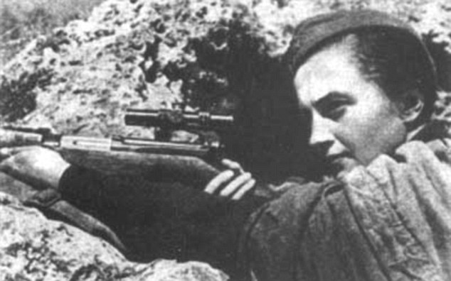
+11

The snipe excelled not just at shooting, but also at all the fieldcraft associated with sniping
‘I found the coldish, chilly metal of the barrel and the receiver pleasant,’ she later wrote.
After briefly becoming acquainted with the weapon, she took her first four shots at a paper target.
The instructor was impressed by the tight grouping of her immensely accurate shots. ‘For a beginner, that is amazing,’ he said. ‘It’s clear you have ability.’
The instructor was right, and for most of the 1930s, and throughout her time as a history student at Kiev National University, Lyudmila honed her skills as a sharpshooter, and even went to an elite sniper school.
There, she excelled not just at shooting, but also at all the fieldcraft associated with sniping.
Despite her valuable talents, when war came it was assumed that, as a woman, she would become a medic.
Even when an officer did agree that her skills should be harnessed in combat, there was a further problem – her unit had a crippling shortage of rifles, and most soldiers were armed only with a single hand grenade.
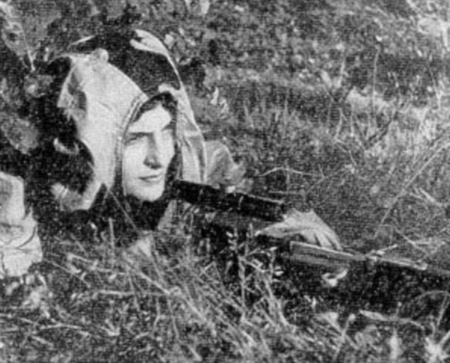
+11

Her unit was based near Odessa, and her targets were two Romanian officers who were stationed in a nearby house
In fact, Lyudmila would only be properly armed when a severely wounded comrade gave her his weapon.
It would not be until August 8, 1941 – seven weeks after Germany and the other Axis powers had invaded the Soviet Union – that Pavlichenko finally made her debut as a sniper.
Her unit was based near Odessa, and her targets were two Romanian officers who were stationed in a nearby house.
Read more: http://www.dailymail.co.uk/news/article-5513463/Stalins-angel-death-worlds-successful-female-sniper.html#ixzz5CS3kWBWJ
Follow us: @MailOnline on Twitter | DailyMail on Facebook

Hiding in a destroyed cottage, Pavlichenko found it was impossible to shoot from a lying position, so she had to take the shots on one knee.
With her targets more than 400 yards away, and with her captain squatting next to her, it was the first time she had fired at human beings.
‘I hit the first target with the third shot and the second one on my fourth attempt,’ she would later write.
It was a less than perfect debut, and her captain admonished her for using too much ammunition.
Nevertheless, with each subsequent ‘kill’ she grew in confidence, and in a letter back home she stated her desire to kill 1,000 of the enemy.
As her autobiography makes clear, it was not a wildly unrealistic ambition. In one encounter alone, she killed 16 Romanians with just 17 shots.
The following day she returned to the same spot and killed ten more.
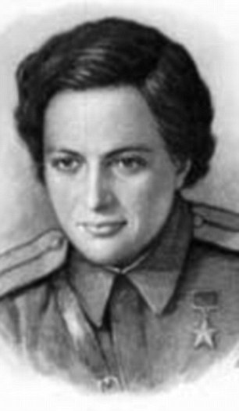
+11

Nevertheless, with each subsequent ‘kill’ she grew in confidence, and in a letter back home she stated her desire to kill 1,000 of the enemy
If Pavlichenko had any misgivings about killing so many, they were assuaged by what the Germans were doing to her people.
The few inhabitants that remained in the villages destroyed by the Nazis told the same tales of plunder and rape, and it was the latter that fuelled Pavlichenko’s lust for vengeance.
‘I did not think “civilised Europe” would also bring this barbarous custom to our land,’ she observed bitterly.
As the months passed, that thirst for vengeance made her dazzlingly effective.
On one occasion, she shinned up a tree to shoot a pair of Romanian machine-gunners at a range of 220 yards.
However, just as she was about to shoot her first target, an officer in the uniform of an adjutant came into view.
Wryly reflecting that he looked ‘most interesting’, Pavlichenko killed him instead.
‘The adjutant did not even cry out as he keeled over,’ she recalled.
‘They began to fuss around him – quite pointlessly, as the bullet had hit him between the eyes.’
Then, quite calmly, Pavlichenko dispatched the two machine-gunners, and with her fourth shot, destroyed the breech of the machine-gun with an armour-piercing bullet, before clambering down the tree under a hail of mortar and rifle fire.
Sniping does not just require an iron nerve, but also an ability to solve complex mathematical problems – and to do so swiftly.
In December 1941, Pavlichenko was targeting some Germans firing a machine-gun from a half-track travelling at an estimated 15mph.
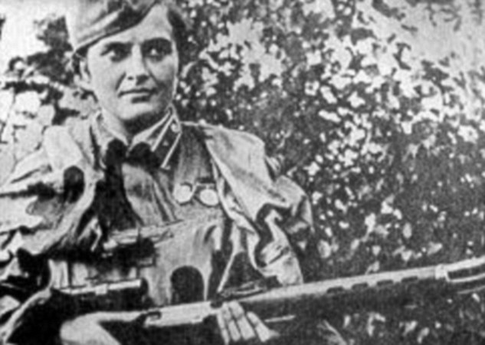
+11

Sniping does not just require an iron nerve, but also an ability to solve complex mathematical problems – and to do so swiftly
‘I had a minute to solve the ballistics problem,’ she later wrote. Knowing her bullet would travel the 220 yards to the target in 0.25 seconds, she established that the vehicle would travel just over four yards in the same amount of time.
‘Using the concept of milliradians in my calculations,’ she recollected, ‘I turned the windage drum on the metal tube of the sight several units, then softly pressed the trigger with my index finger.’
The machine-gunners never knew what hit them.
As Pavlichenko’s tally grew, she was promoted and, as a result, took command of men.
‘The expression of surprise never left their faces,’ she recalled of one unit of naval infantrymen under her command.
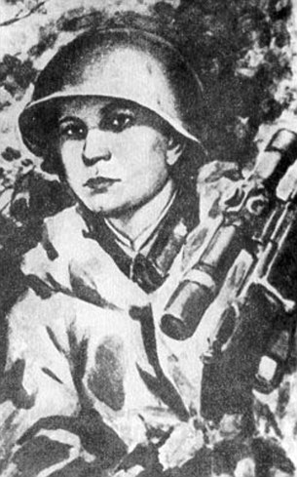
+11

In December 1941, Pavlichenko was targeting some Germans firing a machine-gun from a half-track travelling at an estimated 15mph
But in among the death and suffering, Lyudmila found love.
It came in the form of an officer called Alexei Kitsenko, and they were soon married and sharing a dug-out on the front line.
The couple spent the first few days of their marriage hunting Germans.
‘The honeymoon had a positive effect on my shooting,’ Pavlichenko wrote.
‘The bullets fired well – only along the set trajectory – and seemed to find the target of their own accord.’
But the marriage would not last long. In March 1942 in Sebastopol, Alexei was wounded by a shell.
Although Pavlichenko had been wounded herself at least three times, she knew her husband’s injuries were serious.
Despite medical attention, he died in his wife’s arms.
The effect on Pavlichenko was profound, and she was diagnosed with what would today be called post-traumatic stress disorder.
She was wounded by shell splinters in June 1942 and would spend a month in hospital. She would never return to the front line.
Instead, she spent the rest of the war as a propaganda tool for the Red Army, even visiting the United States and Britain to drum up support for the Russian campaign against the Nazis.
In America, she met not only President Roosevelt but also his wife Eleanor, with whom she struck up an unlikely friendship.
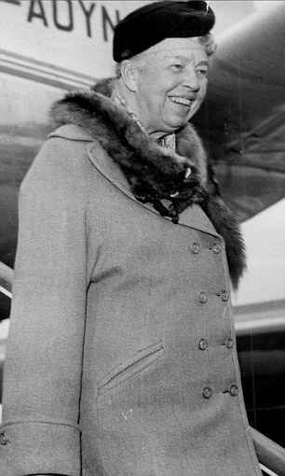
+11

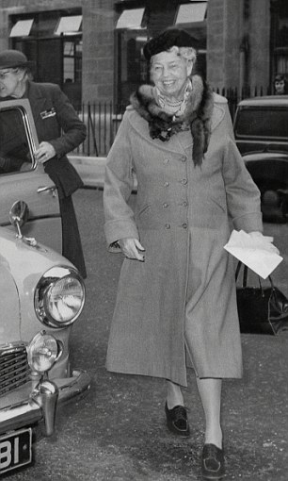
+11

At one point during a long car journey, she awoke, mortified, to discover she had nodded off on Mrs Roosevelt’s shoulder. Mrs Roosevelt is pictured left and right in London in 1959
She recalled: ‘To tell the truth, at the start of the US trip I was prejudiced against Eleanor: aristocrat, millionairess, member of the exploiting class, I thought.
'It never occurred to me I could be of interest to this remarkable woman.’
At one point during a long car journey, she awoke, mortified, to discover she had nodded off on Mrs Roosevelt’s shoulder.
‘Eleanor smiled as if nothing was the matter,’ Pavlichenko recalled.
The Russian found America not to her liking, with inane questioning about the colour of her underwear, and even a marriage proposal from a plutocrat she had barely met.
Bizarrely, the First Lady encouraged her to take up the offer, telling her: ‘You would be marrying a gentleman of means who is madly in love with you and would guarantee you a happy life to the end of your days.
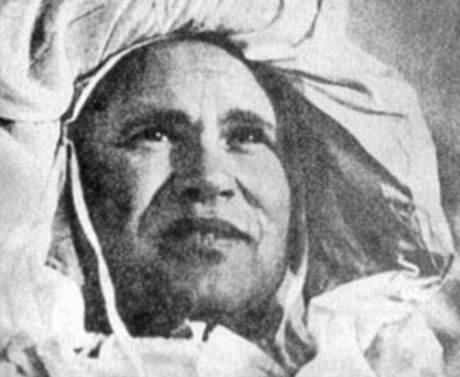
+11

The Russian found America not to her liking, with inane questioning about the colour of her underwear, and even a marriage proposal from a plutocrat she had barely met
'You would remain here and we would be able to meet.’
Pavlichenko demurred but, before she left America, her suitor passed to her, via Mrs Roosevelt, ‘diamond items set in gold, quite luxurious things: a necklace, two bracelets, a brooch and a ring.
'Appended was a docket for $8,000 from a jewellery shop’.
She found Britain more congenial, and she was even granted an audience with Winston Churchill, who asked if the British fog was getting her down.
‘No,’ the sniper replied.
‘Fog is good camouflage. There is probably less trouble from enemy aircraft.’
After the war, Pavlichenko, who had risen to the rank of major, worked as a research assistant for the Soviet navy.
However, she also battled alcoholism, and would die, aged just 58, in 1974.
She never expressed remorse for those she had killed, although she objected to hunting animals for sport.
‘Forest creatures seem to be defenceless and unfortunate in the face of humans armed with rapid-fire rifles,’ she stated.
‘I did not approve of hunting animals and still don’t.’
- Lady Death: The Memoirs Of Stalin’s Sniper, by Lyudmila Pavlichenko with a foreword by Martin Pegler, is published by Greenhill Books, priced £19.99. Offer price £15.99 (20 per cent discount, including free p&p) until March 25. Order at mailshop.co.uk/books or call 0844 571 0640.

Read more: http://www.dailymail.co.uk/news/article-5513463/Stalins-angel-death-worlds-successful-female-sniper.html#ixzz5CS40KrtX
Follow us: @MailOnline on Twitter | DailyMail on Facebook

